TRAINING PROTOCOL
MATERIAL | POSITIONING – PATIENT AND THERAPIST
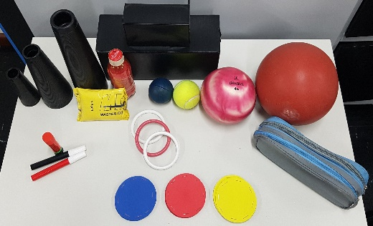  A B  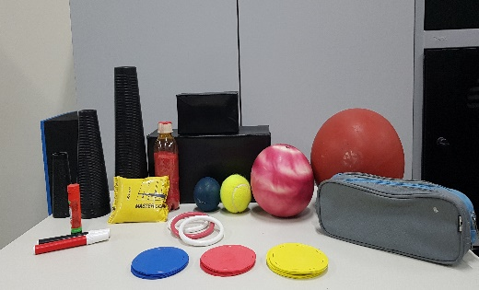  C  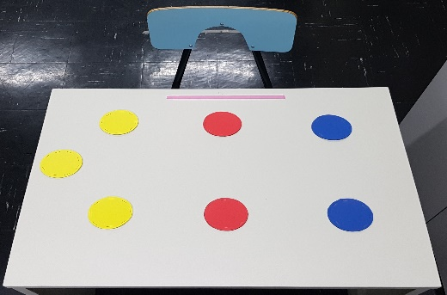  Materials to be used (A e B) and targets positioning for the upper limb aiming movements (C). Materials provide various sensorial stimuli for gross and fine prehension, unilateral and bilateral movements. The objects will also be used as obstacles. Targets will be positioned close and far from the individual in various directions (ipsilateral, contralateral and middle line positions). Pronation and supination will also be practiced. | Image redacted due to potential personal identifiers  Image redacted due to potential personal identifiers  Patient’s position with trunk and lower limb support. The line positioned 3 cm from the border of the table represents the initial position of the upper limb.  Image redacted due to potential personal identifiers  Image redacted due to potential personal identifiers  Therapist’s positioning avoiding patient’s excessive trunk movements and helping movement execution during repetitions, when necessary. Manual contact in the wrist and hand (helping prehension) and in the elbow (helping elbow extension and as support for the limb).
POSITIONING - TARGETS
Close target
Far target
Initial position
Image redacted due to potential personal identifiers

Asking patient to make an aiming movement from the starting position to the targets in various directions and distances (close and far targets). Targets are positioned as far as possible for patient’s movement and the distance is progressively increased. Manual contact from the therapist can be done.

UNILATERAL MOVEMENTS – TASKS AND MATERIALS EXAMPLES
Image redacted due to potential personal identifiers  Image redacted due to potential personal identifiers  Unilateral movement in the middle line position from the close to the far target. Target was positioned as far as possible for the patient. Prehension of a medium size cone was used in this example. | Image redacted due to potential personal identifiers  Image redacted due to potential personal identifiers  Unilateral movement for a target place ipsilateral side to the moving upper limb from the close to the far target. Prehension of a medium size cone with extra weight (0.5 kg) was used in this example.
Image redacted due to potential personal identifiers  Increasing the movement complexity: Unilateral movement to the target placed in the ipsilateral direction of the moving arm. Movement from the close to the far target using arm supination. Prehension of a medium size cone with extra weight (0.5 kg) was used in this example. | Image redacted due to potential personal identifiers  Image redacted due to potential personal identifiers  Unilateral movement to the target placed in the contralateral direction of the moving arm. Movement from the close to the far target. Prehension of a tennis ball.
Image redacted due to potential personal identifiers  Image redacted due to potential personal identifiers  Image redacted due to potential personal identifiers  Increasing the movement complexity: Unilateral movement to the contralateral target and “plugin”. Target is positioned as far as possible for the patient. Fine prehension is stimulated by the hoop.  Image redacted due to potential personal identifiers  Image redacted due to potential personal identifiers  Increasing the movement complexity: Unilateral movement in the same direction of the moving upper limb from the close to the far target positioned on a big box. Prehension of a larger cone. | Image redacted due to potential personal identifiers  Image redacted due to potential personal identifiers  Image redacted due to potential personal identifiers  Increasing the movement complexity: Unilateral movement in the middle line from the close to the far target and obstacle transposition (small box). Prehension of a small cone.
BILATERAL MOVEMENT – TASKS AND MATERIALS EXAMPLES
Image redacted due to potential personal identifiers  Image redacted due to potential personal identifiers  Bilateral movements with upper limbs placed together. Movement from the close to the far target placed on the small box. Prehension of a ball with increased weight (0.5 kg). | Image redacted due to potential personal identifiers  Image redacted due to potential personal identifiers  Bilateral movement with independent position of the upper limbs from the close to the far targets placed in the direction of the upper limbs. Prehension of a larger cone.
Image redacted due to potential personal identifiers  Image redacted due to potential personal identifiers  Increasing the movement complexity: Bilateral movement with upper limbs placed together, holding a ball. Movements are made from the initial position to the ipsilateral target using supination. | Image redacted due to potential personal identifiers  Image redacted due to potential personal identifiers  Increasing the movement complexity: Bilateral movement with upper limbs placed together, holding a kit and changing the direction of the targets, from the middle line to ipsilateral far target.
Image redacted due to potential personal identifiers  Image redacted due to potential personal identifiers  Contact with the table for stabilization: Bilateral movement with upper limbs placed together holding a cone from the close to the far target, in the middle line. The target is placed as far as possible for the patient. | Image redacted due to potential personal identifiers  Image redacted due to potential personal identifiers  Bilateral movement with therapist assistance: Position of the therapist in the diagonal of the hemiparetic side, keeping manual contact. Movement os the upper limbs are synchronized and in-phase or anti-phase.

